SAFEHOMECAM

INTRODUCTION
“SafeHomeCam” is an AI-based home security system designed to recognize faces and hand gestures to trigger specific safety actions.
It combines computer vision, deep learning, and IoT alerting mechanisms to ensure home safety and real-time responsiveness.
The system uses:
• Hand gesture recognition (via a trained CNN model)
• Face recognition for user authentication
• Edge detection and image enhancement for clear input
• Audio alerts and Twilio integration (for message/call alerts)
This project demonstrates how artificial intelligence can be integrated into home automation systems for real-time surveillance, access control, and alert generation.

HYPOTHESIS
By integrating gesture and face recognition modules with edge detection and safety automation, it is hypothesized that:
• The system can accurately recognize hand gestures (Help, Call, Danger, Thumbs Up/Down).
• Unauthorized users will be detected and trigger alarms during SafeHouse Mode.
• Edge-enhancement and contrast techniques will improve detection accuracy in varied lighting conditions.
• Overall, “SafeHomeCam” will enhance home safety through a reliable and intelligent camera-based monitoring system.

OBJECTIVES
• To implement real-time gesture and face recognition using OpenCV and cvzone.
• To enhance camera input using Gamma correction and edge detection.
• To activate audio and alert mechanisms on recognizing danger gestures or unknown faces.
• To design a scalable, easy-to-use safety system for smart homes.

PROCEDURE
1. Setup Environment
- Install dependencies: opencv-python, cvzone, numpy, playsound, face_recognition, twilio, threading.
- Initialize webcam and detectors.
2. Face Recognition
- Capture and encode known user faces.
- Compare live faces with the stored encodings.
- If face is “Unknown” during SafeHouse Mode, trigger siren.
3. Hand Gesture Detection
- Detect hand using cvzone’s HandDetector.
- Preprocess image using:
• Grayscale conversion
• Power law (Gamma) transformation
• Contrast stretching
• Edge detection (Canny)
- Classify gesture using pre-trained Keras model.
4. SafeHouse Mode
- Activated by Thumbs Up gesture.
- Deactivated by Thumbs Down (only if recognized face is owner).
- Alerts triggered for Help, Call, and Danger gestures.
5. Alert Mechanism
- Play alert sounds (alarm.mp3, siren.mp3, Danger.wav).
- (Optional) Send SMS/call via Twilio API.

CODE IMPLEMENTATION

Main.py :-
import cv2
from cvzone.HandTrackingModule import HandDetector
from cvzone.ClassificationModule import Classifier
import numpy as np
import math
import time
from playsound import playsound
from twilio.rest import Client
import face_recognition
import os
import threading
import csv
from datetime import datetime

# ========================== CSV LOGGING ==========================
log_file = os.path.join(os.getcwd(), "gesture_log.csv")

# Create CSV file with headers if not present
if not os.path.exists(log_file):
with open(log_file, mode='w', newline='', encoding='utf-8') as f:
writer = csv.writer(f)
writer.writerow(["Timestamp", "Gesture", "FaceName", "SafeHouseMode", "Message"])

# ========================== CAMERA & DETECTORS ==========================
cap = cv2.VideoCapture(0)
hand_detector = HandDetector(maxHands=1)

# ========================== FACE RECOGNITION ==========================
faces_path = r"C:\Users\prath\OneDrive\Desktop\SafeHomeCam\Data\faces"
images = []
classNames = []
if not os.path.exists(faces_path):
os.makedirs(faces_path)

# Load faces from subfolders (Ayush, Mheet, etc.)
for person_name in os.listdir(faces_path):
person_folder = os.path.join(faces_path, person_name)
if not os.path.isdir(person_folder):
continue
for img_file in os.listdir(person_folder):
img_path = os.path.join(person_folder, img_file)
curImg = cv2.imread(img_path)
if curImg is None:
continue
images.append(curImg)
classNames.append(person_name)

def findEncodings(images):
encodeList = []
for img in images:
img = cv2.cvtColor(img, cv2.COLOR_BGR2RGB)
encodings = face_recognition.face_encodings(img)
if encodings:
encodeList.append(encodings[0])
return encodeList

encodeListKnown = findEncodings(images)

# ========================== GESTURE CLASSIFIER ==========================
classifier = Classifier(
r"C:\Users\prath\OneDrive\Desktop\SafeHomeCam\Model\keras_model.h5",
r"C:\Users\prath\OneDrive\Desktop\SafeHomeCam\Model\labels.txt"
)

with open(r"C:\Users\prath\OneDrive\Desktop\SafeHomeCam\Model\labels.txt", "r") as f:
labels = [line.strip() for line in f.readlines()]

labels = [l.split(maxsplit=1)[-1] if len(l.split()) > 1 else l for l in labels]

offset = 20
imgSize = 300

# ========================== TWILIO SETUP ==========================
account_sid = "ACa8c3a6ec4e9809e86bd009471a4a4473"
auth_token = "5395c627b65140ca30ef8e682f4c79ce"
client = Client(account_sid, auth_token)
twilio_number = "+12298059944"
owner_number = "+918623083659"
police_number = "+918623083659"

# ========================== ALERT & SAFEHOUSE SETTINGS ==========================
last_label = None
last_face_label = None
last_face_location = None
gesture_start_time = 0
triggered = False
hold_duration = 3
frame_count = 0
process_every_n_frames = 3
status_text = ""
status_expire = 0
cooldown_seconds = 5
last_trigger_time = {"Help":0, "Call":0, "Danger":0, "ThumbsUp":0, "ThumbsDown":0}

alarm_path = os.path.join(os.getcwd(), "alarm.wav")
danger_path = os.path.join(os.getcwd(), "Danger.wav")
siren_path = os.path.join(os.getcwd(), "siren.mp3")

safehouse_mode = False
unknown_start_time = 0
unknown_hold_duration = 3

# ========================== UTILITY FUNCTIONS ==========================
def log_event(gesture, face_name, message=""):
"""Log gesture events with face recognition info into a CSV."""
try:
with open(log_file, mode='a', newline='', encoding='utf-8') as f:
writer = csv.writer(f)
writer.writerow([
datetime.now().strftime("%Y-%m-%d %H:%M:%S"),
gesture,
face_name if face_name else "Unknown",
"ON" if safehouse_mode else "OFF",
message
])
except Exception as e:
print(f"[LOG ERROR] Could not write to CSV: {e}")

def safe_play(path):
if os.path.isfile(path):
try:
from playsound import playsound
playsound(path)
except:
pass

def set_status(text, duration=3):
global status_text, status_expire
status_text = text
status_expire = time.time() + duration

def send_sms_sync(to, message):
try:
msg = client.messages.create(body=message, from_=twilio_number, to=to)
return ("ok", getattr(msg, "sid", None))
except Exception as e:
return ("error", str(e))

def make_call_sync(to, message):
try:
call = client.calls.create(twiml=f'<Response><Say>{message}</Say></Response>', from_=twilio_number, to=to)
return ("ok", getattr(call, "sid", None))
except Exception as e:
return ("error", str(e))

def async_send_sms(to, message):
def job():
res = send_sms_sync(to, message)
set_status(f"SMS -> {to}: {res[0]}", 4)
threading.Thread(target=job, daemon=True).start()

def async_make_call(to, message):
def job():
res = make_call_sync(to, message)
set_status(f"Call -> {to}: {res[0]}", 4)
threading.Thread(target=job, daemon=True).start()

def trigger_actions(label):
global safehouse_mode, unknown_start_time, last_face_label

gesture_name = label.replace(" ", "").strip()

if gesture_name not in ["Help", "Call", "Danger", "ThumbsUp", "ThumbsDown"]:
return

now = time.time()
if now - last_trigger_time.get(gesture_name, 0) < cooldown_seconds:
set_status(f"{gesture_name} (cooldown)", 2)
return
last_trigger_time[gesture_name] = now

# ============================ SAFEHOUSE CONTROL (Only Pratham) ============================
if gesture_name == "ThumbsUp":
if last_face_label == "Pratham":
safehouse_mode = True
unknown_start_time = 0
set_status("SafeHouse Mode ON (Authorized: Pratham)", 5)
log_event("ThumbsUp", last_face_label, "SafeHouse Mode turned ON")
else:
set_status("Access Denied: Only Mheet can turn ON SafeHouse Mode", 5)
log_event("ThumbsUp", last_face_label, "Access Denied")

elif gesture_name == "ThumbsDown":
if last_face_label == "Pratham":
safehouse_mode = False
set_status("SafeHouse Mode OFF (Authorized: Pratham)", 5)
unknown_start_time = 0
log_event("ThumbsDown", last_face_label, "SafeHouse Mode turned OFF")
else:
set_status("Access Denied: Only Pratham can turn OFF SafeHouse Mode", 5)
log_event("ThumbsDown", last_face_label, "Access Denied")

elif gesture_name == "Help":
set_status("HELP triggered", 5)
threading.Thread(target=safe_play, args=(danger_path,), daemon=True).start()
async_send_sms(owner_number, "🚨 HELP detected! Immediate assistance may be required.")
log_event("Help", last_face_label, "HELP gesture triggered")

elif gesture_name == "Call":
set_status("CALL triggered", 5)
async_make_call(owner_number, "Emergency call request received. Please check immediately.")
async_send_sms(owner_number, "📞 CALL gesture detected. Call initiated.")
log_event("Call", last_face_label, "CALL gesture triggered")

elif gesture_name == "Danger":
set_status("DANGER triggered", 6)
threading.Thread(target=safe_play, args=(danger_path,), daemon=True).start()
async_send_sms(owner_number, "⚠️ DANGER ALERT! Something unusual detected.")
async_send_sms(police_number, "🚨 Possible threat detected at the registered address.")
async_make_call(owner_number, "Danger alert triggered! Authorities have been notified.")
log_event("Danger", last_face_label, "DANGER gesture triggered")

# ========================== MAIN LOOP ==========================
while True:
success, img = cap.read()
if not success:
break
imgOutput = img.copy()
frame_h, frame_w = img.shape[:2]

hands, img = hand_detector.findHands(img, flipType=False)
detected_region = None
region_type = None
label = None
frame_count += 1

# ----- PRIORITIZE HAND if visible -----
if hands:
hand = hands[0]
x, y, w, h = hand['bbox']
detected_region = (x, y, w, h)
region_type = "hand"

# ----- Run face recognition every 5th frame (always, even with hands)
frame_count += 1
if frame_count % 5 == 0:
imgS = cv2.resize(img, (0, 0), None, 0.25, 0.25)
imgS = cv2.cvtColor(imgS, cv2.COLOR_BGR2RGB)
facesCurFrame = face_recognition.face_locations(imgS)
encodesCurFrame = face_recognition.face_encodings(imgS, facesCurFrame)

if facesCurFrame:
for encodeFace, faceLoc in zip(encodesCurFrame, facesCurFrame):
matches = face_recognition.compare_faces(encodeListKnown, encodeFace)
faceDis = face_recognition.face_distance(encodeListKnown, encodeFace)
matchIndex = np.argmin(faceDis)

if matches[matchIndex]:
name = classNames[matchIndex]
last_face_label = name
last_face_location = faceLoc
else:
last_face_label = "Unknown"
last_face_location = faceLoc
else:
last_face_label = None
last_face_location = None

# ---- Draw last known face box every frame ----
if last_face_location is not None:
y1, x2, y2, x1 = last_face_location
y1, x2, y2, x1 = y1 * 4, x2 * 4, y2 * 4, x1 * 4
cv2.rectangle(imgOutput, (x1, y1), (x2, y2), (255, 0, 255), 2)
cv2.putText(imgOutput, last_face_label, (x1, y2 + 30),
cv2.FONT_HERSHEY_SIMPLEX, 0.75, (255, 0, 255), 2)

# ================= SAFEHOUSE: unknown person hold detection (one-time alert + limited capture) =================

if safehouse_mode:
if last_face_label == "Unknown":
if unknown_start_time == 0:
unknown_start_time = time.time()
elif time.time() - unknown_start_time >= unknown_hold_duration:
if not captured_once:
set_status("UNKNOWN detected during SafeHouse Mode!", 6)
threading.Thread(target=safe_play, args=(siren_path,), daemon=True).start()

# ---- Create folder if not exists ----
capture_dir = os.path.join(os.getcwd(), "Captured_Frames")
os.makedirs(capture_dir, exist_ok=True)

# ---- Capture up to 5 images ----
timestamp = time.strftime("%Y%m%d_%H%M%S")
for i in range(5):
filename = os.path.join(capture_dir, f"Unknown_{timestamp}_{i+1}.jpg")
cv2.imwrite(filename, imgOutput)
time.sleep(0.3)

# ---- Send alerts only once ----
threading.Thread(target=safe_play, args=(danger_path,), daemon=True).start()
async_send_sms(owner_number, "Unknown person detected during SafeHouse Mode! 5 images captured.")
async_send_sms(police_number, "Possible intrusion detected at SafeHouse.")
async_make_call(owner_number, "Unknown person detected during SafeHouse Mode. Authorities have been notified.")

captured_once = True # prevent repeating siren & alerts
log_event("UnknownFace", "Unknown", "Unknown person detected during SafeHouse Mode")
else:
# Reset when a known person appears
unknown_start_time = 0
captured_once = False

# ================= HAND PROCESSING & CLASSIFICATION =================
if detected_region and region_type == "hand":
x, y, w, h = detected_region
imgWhite = np.ones((imgSize, imgSize, 3), np.uint8) * 255
y1, y2 = max(0, y - offset), min(frame_h, y + h + offset)
x1, x2 = max(0, x - offset), min(frame_w, x + w + offset)
imgCrop = img[y1:y2, x1:x2]

if imgCrop.size != 0:
# ---- Exp 4–5 : Grayscale Conversion (Filtering / Sharpening) ----
gray = cv2.cvtColor(imgCrop, cv2.COLOR_BGR2GRAY)
# ---- Exp 2 : Contrast Stretching ----
min_val, max_val = np.min(gray), np.max(gray)
if max_val - min_val > 0:
gray = ((gray - min_val) / (max_val - min_val)) * 255
gray = np.uint8(gray)
# ---- Exp 1 : Power Law Transformation (Gamma Correction) ----
gamma = 1.5
gray = np.array(255 * (gray / 255) ** gamma, dtype='uint8')
# ---- Exp 8 : Edge Detection (Canny) ----
edges = cv2.Canny(gray, 100, 200)
# ---- Convert Back for Display / Classification ----
imgEnhanced = cv2.cvtColor(edges, cv2.COLOR_GRAY2BGR)

aspectRatio = h / w
try:
if aspectRatio > 1:
k = imgSize / h
wCal = math.ceil(k * w)
imgResize = cv2.resize(imgCrop, (wCal, imgSize))
wGap = math.ceil((imgSize - wCal) / 2)
imgWhite[:, wGap:wCal + wGap] = imgResize
else:
k = imgSize / w
hCal = math.ceil(k * h)
imgResize = cv2.resize(imgCrop, (imgSize, hCal))
hGap = math.ceil((imgSize - hCal) / 2)
imgWhite[hGap:hCal + hGap, :] = imgResize
except Exception:
pass

cv2.imshow('ImageCrop_Enhanced', imgEnhanced)
cv2.imshow('ImageWhite', imgWhite)

try:
prediction, index = classifier.getPrediction(imgWhite, draw=False)
if index < len(labels):
label = labels[index]
except Exception:
pass

# ================= DRAWING =================
if detected_region:
x, y, w, h = detected_region
color = (0, 255, 0) if region_type == "hand" else (255, 0, 0)
cv2.rectangle(imgOutput, (x - offset, y - offset), (x + w + offset, y + h + offset), color, 3)
label_text = label if label is not None else ""
if region_type == "face":
cv2.putText(imgOutput, f"FACE: {label_text}", (x, y - 15), cv2.FONT_HERSHEY_SIMPLEX, 0.9, color, 2)
else:
cv2.putText(imgOutput, f"HAND: {label_text}", (x, y - 15), cv2.FONT_HERSHEY_SIMPLEX, 0.9, color, 2)

if label:
cv2.putText(imgOutput, f"Detected: {label}", (10, 50), cv2.FONT_HERSHEY_SIMPLEX, 1.0, (0,0,255), 2)

if label and region_type == "hand":
current_time = time.time()

# Reset timer if a new gesture appears
if label != last_label:
last_label = label
gesture_start_time = current_time
triggered = False

elapsed = current_time - gesture_start_time

# Only if the same gesture is held continuously
if elapsed < hold_duration:
pct = elapsed / hold_duration
cv2.rectangle(imgOutput, (10, 80), (int(10 + 200 * pct), 100), (0, 255, 0), -1)
cv2.rectangle(imgOutput, (10, 80), (210, 100), (255, 255, 255), 2)
remaining = max(0, int(hold_duration - elapsed))
cv2.putText(imgOutput, f"Holding {remaining}s", (220, 95),
cv2.FONT_HERSHEY_SIMPLEX, 0.6, (255, 255, 255), 1)
elif not triggered:
triggered = True
set_status(f"{label} gesture triggered after 3s", 4)
trigger_actions(label)
else:
# Reset timer if hand not visible
last_label = None
gesture_start_time = 0
triggered = False

if safehouse_mode:
cv2.putText(imgOutput, "SAFEHOUSE MODE ON", (10, 130), cv2.FONT_HERSHEY_SIMPLEX, 0.8, (0,255,0), 2)
if last_face_label == "Unknown" and unknown_start_time != 0:
remaining = max(0, int(unknown_hold_duration - (time.time() - unknown_start_time)))
cv2.putText(imgOutput, f"Unknown hold: {remaining}s", (10, 160), cv2.FONT_HERSHEY_SIMPLEX, 0.7, (0,200,200), 2)

if status_text and time.time() < status_expire:
cv2.putText(imgOutput, status_text, (10, 30), cv2.FONT_HERSHEY_SIMPLEX, 0.8, (0,0,255), 2)
elif status_text and time.time() >= status_expire:
status_text = ""

cv2.namedWindow("SafeHomeCam", cv2.WINDOW_NORMAL)
cv2.setWindowProperty("SafeHomeCam", cv2.WND_PROP_TOPMOST, 1)
cv2.imshow("SafeHomeCam", imgOutput)

if cv2.waitKey(1) & 0xFF == ord('q'):
break

cap.release()
cv2.destroyAllWindows()

Training and Testing of the model using Teachable Machine
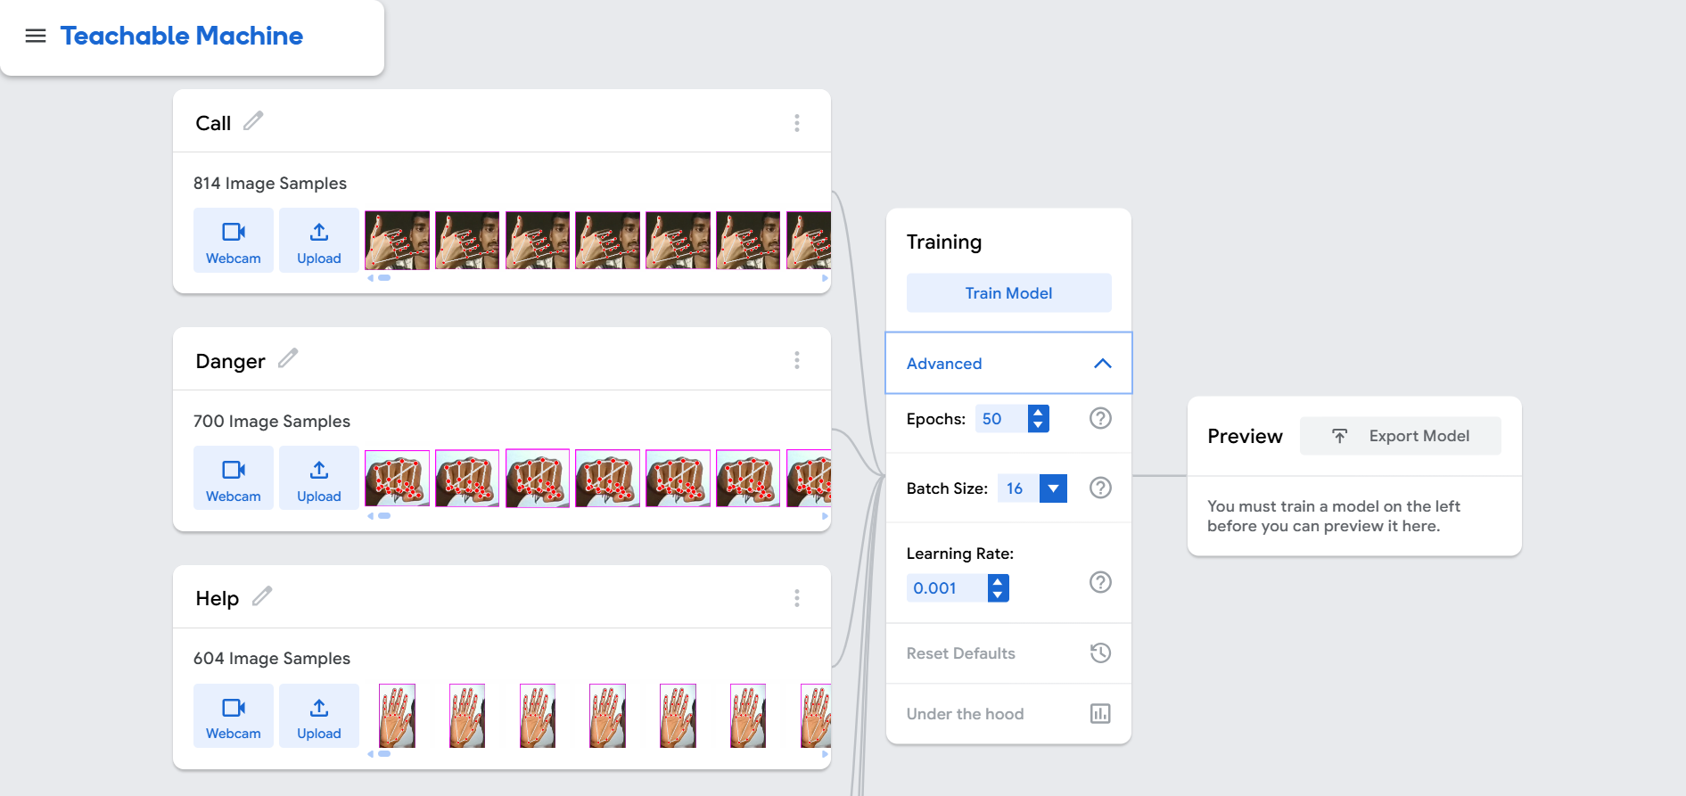
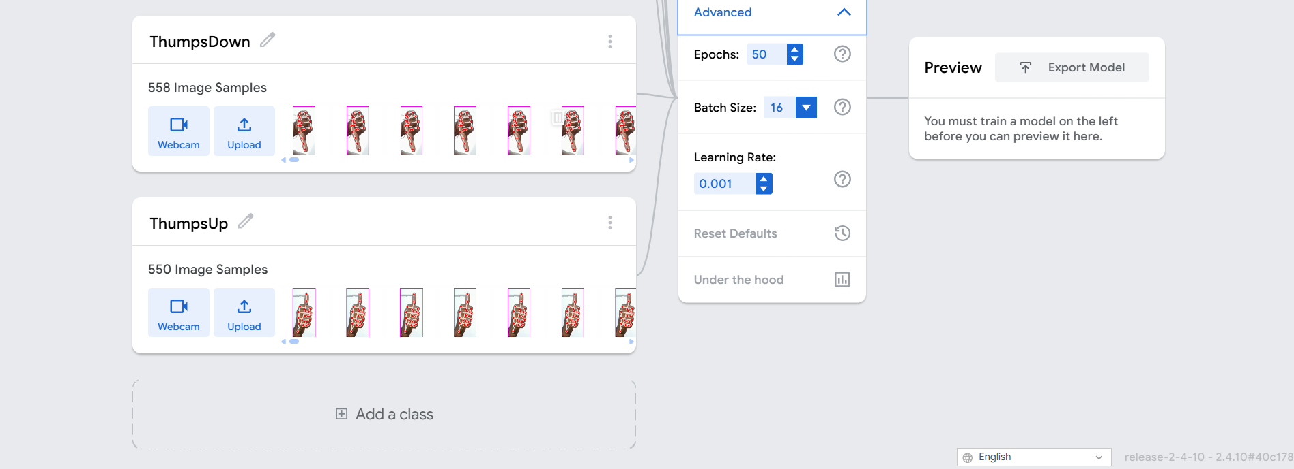

RESULTS
Test Case | Input | System Response
Known face + Thumbs Up | Gesture detected | SafeHouse Mode ON
Unknown face + SafeHouse Mode | Detected for 3 seconds | Siren and alert message
Help gesture | Detected | Alarm sound triggered
Thumbs Down (with owner face) | Detected | SafeHouse Mode OFF
Here is the live camera feed output :-

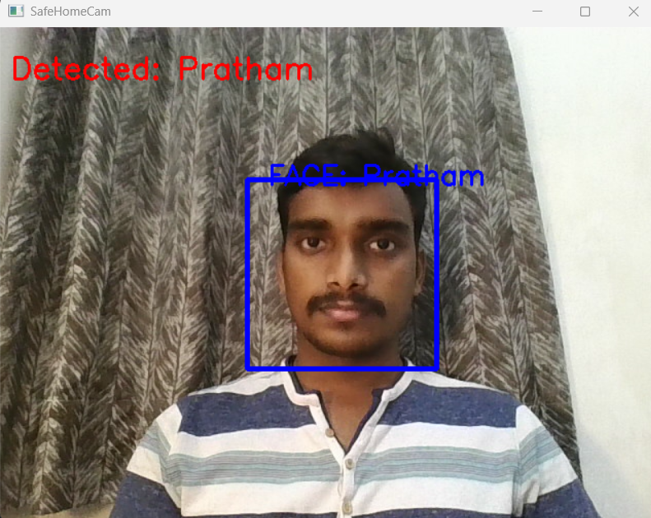
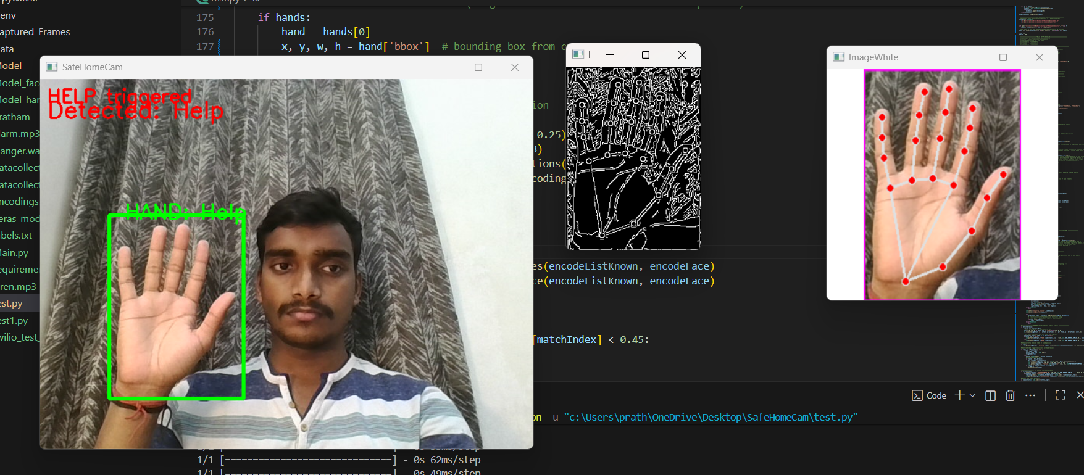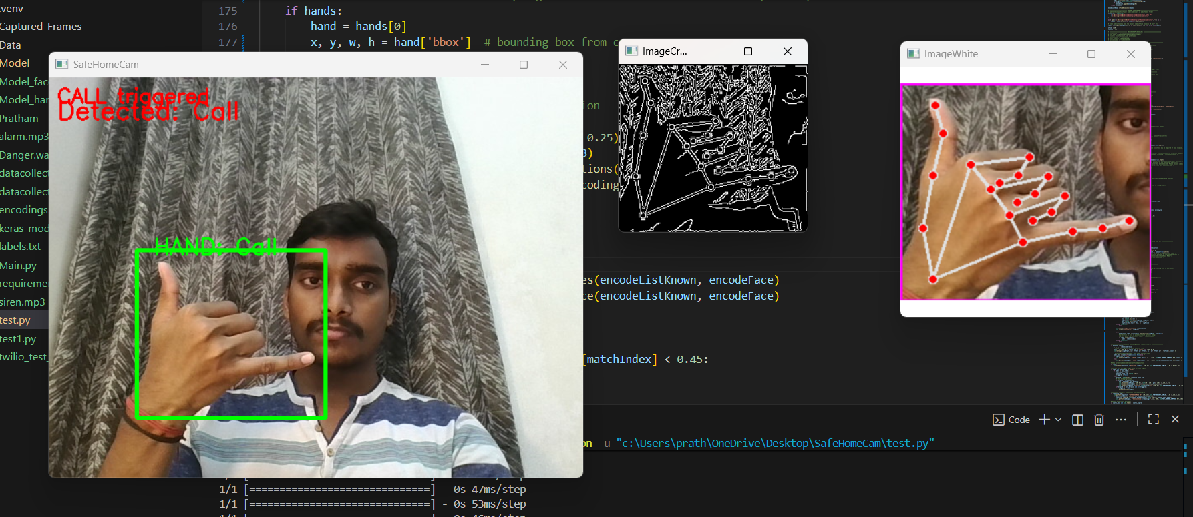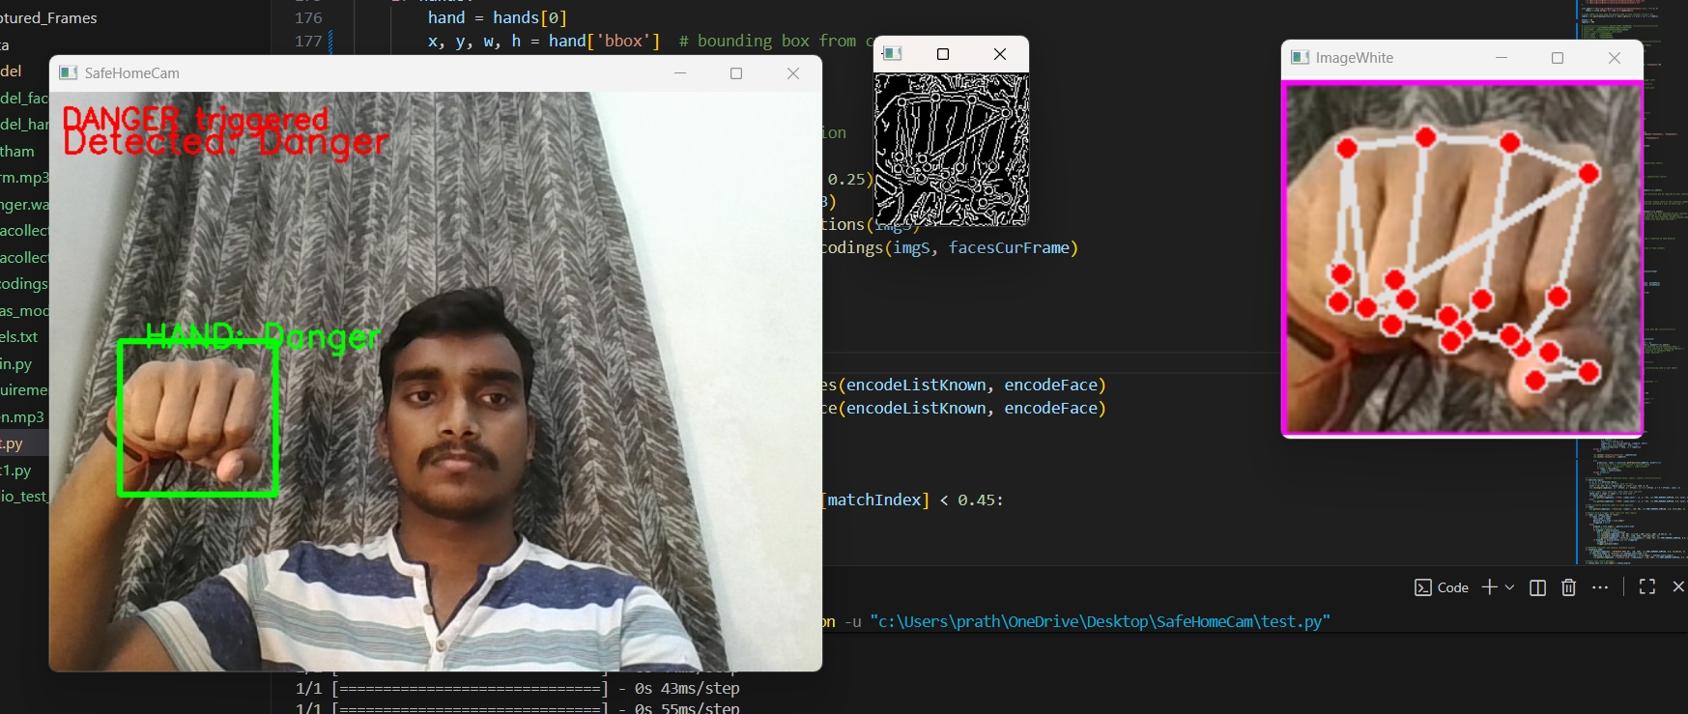
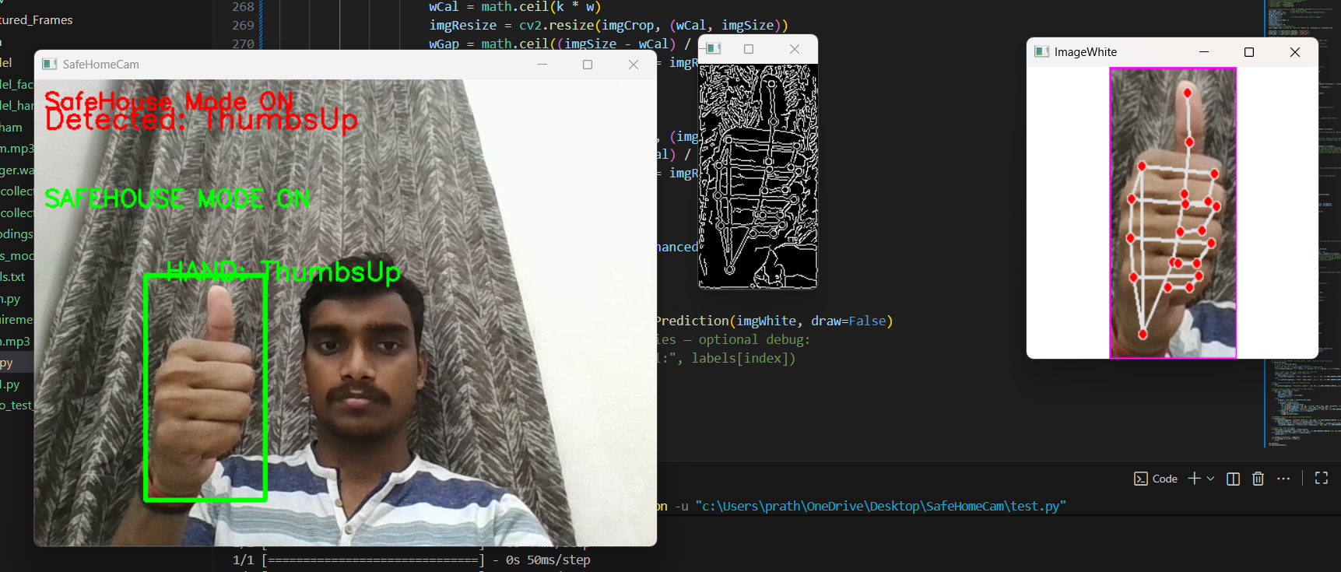
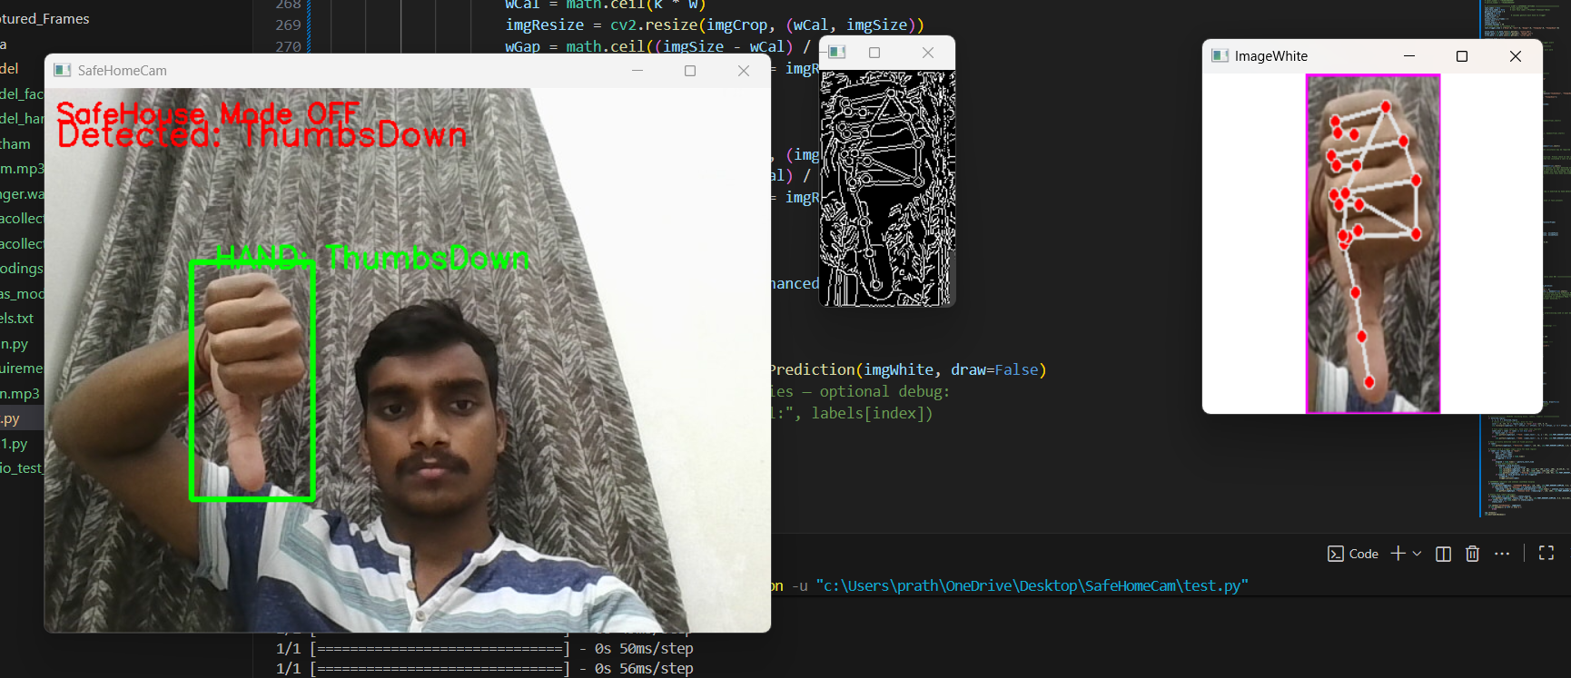

DISCUSSION
• Edge detection improves gesture clarity and recognition accuracy.
• Gamma correction balances brightness in low-light conditions.
• SafeHouse Mode effectively monitors and restricts unknown access.
• The modular structure allows easy expansion (e.g., more gestures, cloud alerts).

CONCLUSION
“SafeHomeCam” successfully integrates gesture recognition, face authentication, and alert automation to build an intelligent home safety system.
It demonstrates the potential of computer vision and AI in enhancing household security.
By combining real-time detection with audio and IoT-based alerts, this system lays the foundation for smart, self-learning surveillance solutions.

FUTURE SCOPE
• Add mobile app connectivity for live monitoring.
• Implement cloud-based data storage and logging.
• Enhance recognition model using deep CNNs for higher accuracy.
• Integrate object detection to detect suspicious movements.

REFERENCES
• OpenCV Documentation: https://docs.opencv.org
• cvzone Library: https://github.com/cvzone
• Twilio API Documentation: https://www.twilio.com/docs
• face_recognition Library: https://github.com/ageitgey/face_recognition

